Course 2 Question and Answers :

Related to content : Part I Basics of AODV and DSR part II II Evaluation of performance

Part I AODV DSR basics Materials : Read the slides : Chapter 2 s27-S35

Q1 About the functioning of DSR

What is the type of routing :

Explain the slides in few sentences

Q2 How DSR manages the route failure ?

Q3 wat are the main DSR messages

AODV basics Materials : Read the slides Chapter 2 s43-S51

Q1 About the functioning of AODV

What is the type of routing

Explain the slides in few sentences

Q2 how AODV manages the route failure

Q3 wat are the main AODV messages

Part II AODV and DSR Performances

Read the paper

*Performance Comparison of Two On-Demand Routing Protocols forAd Hoc Networks*

Charles E. Perkins, Elizabeth M. Royer, Samir R. Das and Mahesh K. Marina,

IEEE Personal Communications • February 2001

Comment the figure 3 about the routing load

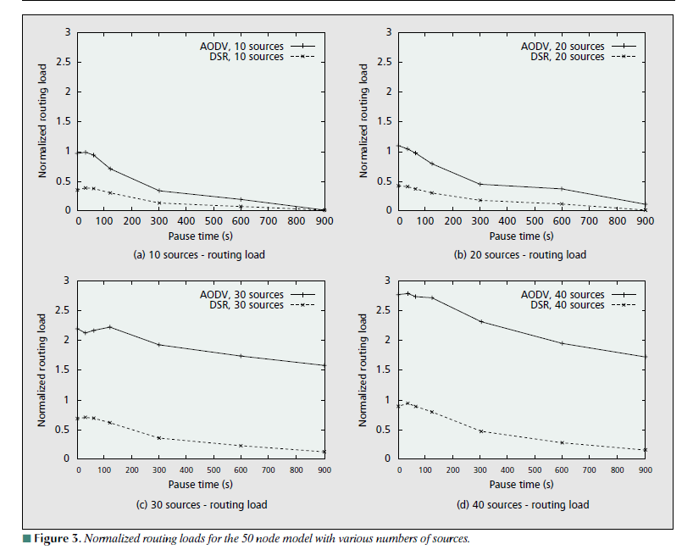

What is the unit to count the routing load

What are the main pakets participation to the routing load in AODV, in DSR

Why ?

Comment the figure in slides 55

